Experiment 6: Identification of Lowercase Letters Using LEX

1. Aim
To write a LEX program to identify lowercase letters in the given input and display the lowercase characters.

2. Algorithm
- Start the program.
- Define the LEX rules to recognize lowercase letters from a to z.
- Display a message asking the user to enter the input.
- Call the yylex() function to scan the input.
- If a lowercase letter is encountered, display the message "is lowercase" along with the character.
- If a newline is encountered, terminate the scanning process.
- Stop the program.

3. Pseudocode
BEGIN
Display "Enter the lexeme:"
Call yylex()

WHILE input is available
IF character is between 'a' and 'z'
Display character and "is lowercase"
ELSE IF newline is encountered
Stop scanning
END IF
END WHILE

Return 0
END

3. Code
%{
#include <stdio.h>
%}

%%
[a-z]+ { printf("%s is lowercase\n", yytext); }
[A-Z]+ { printf("%s is uppercase\n", yytext); }
\n { return 0; }
. { }
%%

int yywrap()
{
return 1;
}

int main()
{
printf("Enter the lexeme: ");
yylex();
return 0;
}

INPUT
Enter the lexeme: hello
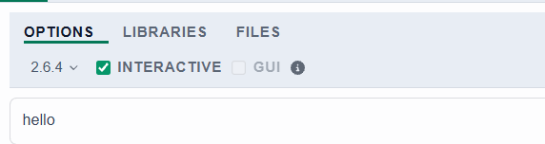

OUTPUT
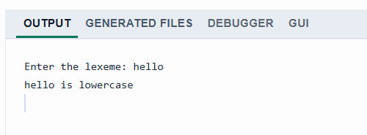

RESULT
Thus, the Lex program to identify and display lowercase alphabetic characters was successfully implemented and executed.

